**Diabatic Retinopathy**

**Abstract:**

In proposed work deep learning technique is applied for explaining a neural network for diabetic retinopathy detection. Machine learning with deep neural network helps to solve different problems. This method explains intermediate layers, filtering out unimportant units by their attribution value and generating training and validation graph. Moreover, the visualization results extend the use of diabetic retinopathy detection model from merely predicting the disease.

**1)Introduction:**

Neural networks or artificial neural networks become a productive tool to solve real world problems. The use of algorithms works intelligently and percept to make algorithms logically strong. These system learn to do tasks conventionally as well as unconventionally. There are several different types of neural networks which works for several conditions. It also works for classification and prediction tasks. Convolutional neural networks with machine learning did many evolution in prediction of diseases in field of medical science.

The detection of infected images of diabetic retinopathy is our concern in proposed work. Diabetic retinopathy is an eye disease which is caused due to diabetes. This disease cause blindness and it has different types which are develop in different patients. This disease become severe if diabetes is not controlled. Sometime not such symptoms are felt but retinopathy suddenly cause blindness.

**2)Literature Review :**

Nazir, T., Irtaza, A., presented a novel method [1] from which many stages of DR were detected using extreme learning machines(EML). The feature classification was done using ELM. The use of tetragonal patterns have also make detection task convenient. The proposed method was also compared with existing methods datasets and shows accuracy.

[RishabGargeya](https://www.sciencedirect.com/science/article/pii/S0161642016317742" \l "!)[1](https://www.sciencedirect.com/science/article/pii/S0161642016317742" \l "!),[TheodoreLeng](https://www.sciencedirect.com/science/article/pii/S0161642016317742#!) presented a paper [2] in which they introduced method of Deep learning automated technique to identify Diabetic Retinopathy(DR). The objective of this paper was early detection and treatment of patients suffered from DR. The proposed artificial intelligent algorithm works on images and did their classification to identify that either the patient was effected or not with DR disease.

In this paper [Varun Gulshan,](https://jamanetwork.com/searchresults?author=Varun+Gulshan&q=Varun+Gulshan)[Lily Peng,](https://jamanetwork.com/searchresults?author=Lily+Peng&q=Lily+Peng) [Marc Coram,](https://jamanetwork.com/searchresults?author=Marc+Coram&q=Marc+Coram)[3] presented technique which detect DR and diabetic macular edema from images. The convolutional neural networks were used to train retinal photographs and identify the type of disease. The algorithm was used to estimate two sets one for specify and other for check sensitivity.

[Ryan Lee](https://eandv.biomedcentral.com/articles/10.1186/s40662-015-0026-2#auth-1), [Tien Y. Wong](https://eandv.biomedcentral.com/articles/10.1186/s40662-015-0026-2#auth-2), [Charumathi Sabanayagam](https://eandv.biomedcentral.com/articles/10.1186/s40662-015-0026-2#auth-3) have presented a review paper[4] in which they compared different methods to identify risk issues occur during cure of DR. different charts were used for comparison of factors. The progression and regression were also focused for discovery of symptoms of retinopathy. Many of features were updated by reviewing the past work of this field.

Solomon, S. D., Chew, E in paper[5] have suggested two techniques ACCORD study and FIELD which helps in find that dyslipidaemia causes DR. The results of this research shows that fenofibrates are beneficial to cure the patients of retinopathy. The successful trails were actually performed by two clinics and no side effects was evident.

Krause, J., Gulshan, V presented a paper [6] in which they use retrospective analysis in grading based retinopathy on fundus images. Adjudication was used to compute errors in DR and reduce them. Grading also classifies the severity of DR that either it is minor or worse. It also compute area under curve and checks the sensitivity.

In this paper Pratt, H., Coenen, F.,[7] have proposed convolutional neural network approach for diagnostic purpose of DR. This technique finds the severity of disease and classify it from fundus images. The network is trained on GPU and Kaggle dataset, it works accurately for identification and classification of DR features.

Ting, D. S. W., Cheung, C. Y. L[8] have used the machine learning technique and neural networks technique. The images from multiethnic population were screened and use to construct an authenticated system which helped in DR detection. A deep learning system(DLS) not only accurately find DR but also other eye diseases.

Bhatia, K., Arora, S., & Tomar, R. presented review paper [9] in which they have discussed some machine learning algorithms(i.e. Naïve Bayes, SVM etc) for the purpose of classification. The automated system emphasis on the detection of DR by processing images and make decisions about feature classification. the idea of intelligent system was also proposed in this paper.

Li, L., Fredrikson, M., Sen, S., & Datta, A [10], have proposed integrated gradients for DR detection. This technique was used to measure quantities, hidden layers and excludes insignificant attributes from dataset. The transfer learning was use to classify DR stages and did prediction about the disease in constructive manner.

**3)Methodology and Experiment:**

**3.1) Data set selection:**

In order to bring about the experiments and executions I use google colaboratory. For our experimentation I have used Diabetic retinopathy dataset available at Kaggle. The dataset consists of 5 different classes of retinopathy affected images.

**3.2) Data set pre-processing:**

There are a few strategies to process information utilizing Google Colab. One of them is to just transfer the information to your Google drive. I utilized the informational collection for diabetic retinopathy that is accessible on Kaggle. Mount drive to preprocess data easily on Google Colab, but before TensorFlow is installed.

**3.3) Defining modal:**

For preparing the model, we require images dataset. Approval pictures and their comparing genuine marks. We additionally characterize the diseased images in this progression. First of all, we will run the model for 5 given classes. In next step we give labels to images as given dataset. In defining model we also use layers like convolutional layer, batch normalization layer, dense layer etc. complete summary of model is shown below.

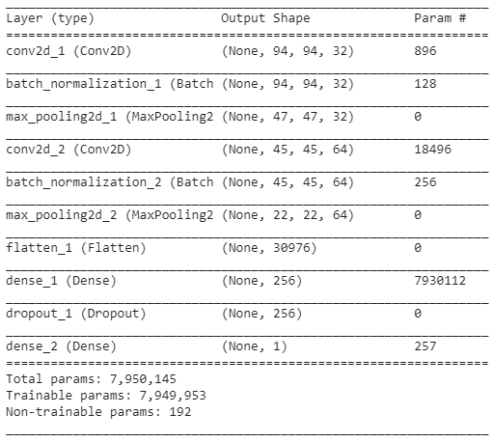

**3.4) Training the modal:**

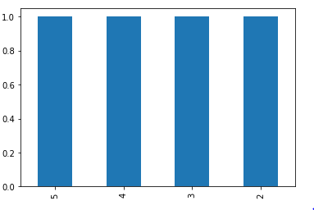For training, normal Adam optimizer is applied and categorical cross entropy is the loss function. The test size is0.20 no random 42 state. The training data is highly unbalanced, as about comparing to that only about 2.02% samples are labelled as stage 2 to 5. Therefore, if trained with batch data directly drawn from training set, the classifier would be too biased toward stage 0. So, we divide the training set by the label and randomly select samples from each label set with fixed weights. It can prevent too much difference between dataset distribution and actual training distribution, and reflect a trade-off between balance and accuracy.

**3.5) Training and validation generator:**

The length of training process is not measured by epochs but by mini-batches because the adjustment by weight makes the training data be picked out randomly, not sequentially. The mini-batch size is 50 samples. At the beginning of each training phase, we pick out 10 epoch per step of training set and validation set. The whole training process takes about seconds. We use Keras library with TensorFlow as backend.

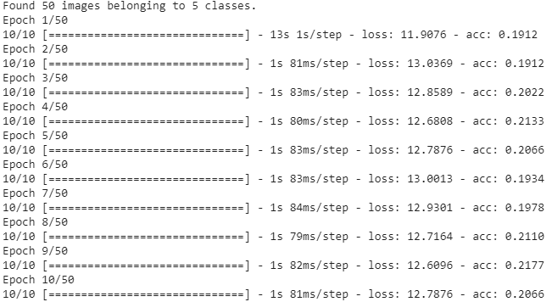

The whole training process takes about seconds. We use Keras library with TensorFlow as backend. Training and validation helps to plot the bar graph and shows that how generator works.

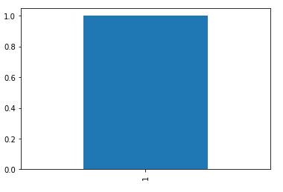

**3.6) Fit and save model:**

When the generated values give accurate result the model is stored in google drive easily and the access easily when required.

**3.7) Virtualize training:**

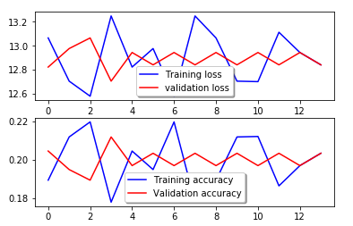Here are the virtualization of model shows training and validation losses. In proposed work the results were not so good but the change of learning rate and training it many times gives better results. This model also give training and validation accuracy.

**5)Conclusion :**

In proposed method machine learning and deep neural network were used and this paper jelps to show the flow of work used in image classification. In proposed work the results were not so good but the change of learning rate and training it many times gives better results. This model also give training and validation accuracy.

**References**:

[1] Nazir, T., Irtaza, A., Shabbir, Z., Javed, A., Akram, U., & Mahmood, M. T. (2019). Diabetic Retinopathy Detection through Novel Tetragonal Local Octa Patterns and Extreme Learning Machines. *Artificial Intelligence in Medicine*.

[2]Gargeya, R., & Leng, T. (2017). Automated identification of diabetic retinopathy using deep learning. *Ophthalmology*, *124*(7), 962-969.

[3]Gulshan, V., Peng, L., Coram, M., Stumpe, M. C., Wu, D., Narayanaswamy, A., ... & Kim, R. (2016). Development and validation of a deep learning algorithm for detection of diabetic retinopathy in retinal fundus photographs. *Jama*, *316*(22), 2402-2410.

[4] Lee, R., Wong, T. Y., & Sabanayagam, C. (2015). Epidemiology of diabetic retinopathy, diabetic macular edema and related vision loss. *Eye and vision*, *2*(1), 17.

[5] Solomon, S. D., Chew, E., Duh, E. J., Sobrin, L., Sun, J. K., VanderBeek, B. L., ... & Gardner, T. W. (2017). Diabetic retinopathy: a position statement by the American Diabetes Association. *Diabetes care*, *40*(3), 412-418.

[6] Krause, J., Gulshan, V., Rahimy, E., Karth, P., Widner, K., Corrado, G. S., ... & Webster, D. R. (2018). Grader variability and the importance of reference standards for evaluating machine learning models for diabetic retinopathy. *Ophthalmology*, *125*(8), 1264-1272.

[7] Pratt, H., Coenen, F., Broadbent, D. M., Harding, S. P., & Zheng, Y. (2016). Convolutional neural networks for diabetic retinopathy. *Procedia Computer Science*, *90*, 200-205.

[8] Ting, D. S. W., Cheung, C. Y. L., Lim, G., Tan, G. S. W., Quang, N. D., Gan, A., ... & Wong, E. Y. M. (2017). Development and validation of a deep learning system for diabetic retinopathy and related eye diseases using retinal images from multiethnic populations with diabetes. *Jama*, *318*(22), 2211-2223.

[9] Bhatia, K., Arora, S., & Tomar, R. (2016, October). Diagnosis of diabetic retinopathy using machine learning classification algorithm. In *2016 2nd International Conference on Next Generation Computing Technologies (NGCT)* (pp. 347-351). IEEE.

[10] Li, L., Fredrikson, M., Sen, S., & Datta, A. (2017). Case study: explaining diabetic retinopathy detection deep CNNs via integrated gradients. *arXiv preprint arXiv:1709.09586*.